**Software Project Management Plan**

Voice Controlled Drone

Aldwin Akbar Hermanudin

Rudy Nurhadi

Tomi

**Software Project Management Plan**

**for**

***Voice Controlled Drone***

***Aldwin Akbar, Rudy Nurhadi, Tomi***

***September 29th 2015***

|  |  |  |  |
| --- | --- | --- | --- |
| **Version** | **Release Date** | **Responsible Party** | **Major Changes** |
| 0.1 | September 29th 2015 | Team Leader | First Draft |
|  |  |  |  |
|  |  |  |  |
|  |  |  |  |
|  |  |  |  |
|  |  |  |  |

***Table of Contents***

Cover1

Table of Contents4

1. Introduction

1. 1 Project Overview5

1. 2 Project Deliverables5

1. 3 Evolution of the SPMP5

1. 4 Reference Materials6

1.5 Definitions and Acronyms6

2. Project Organization

2. 1 Process Model8

2. 2 Organizational Structure9

2. 3 Project Responsibilities9

3. Managerial Process

3.1 Management Objectives and Priorities10

3.2 Assumptions, Dependencies, and Constraints10

3.3 Risk Management10

3.4 Monitoring and Controlling Mechanisms13

3.5 Staffing Approach13

4. Technical Process

4. 1 Methods, Tools, and Techniques14

4. 2 Software Documentation14

4.2.1 Software Requirements Specifications (SRS)14

4.2.2 Software Design Description14

4.2.3 Software Test Plan14

4. 3 User Documentation14

4. 4 Project Support Functions15

5. Work Packages, Schedule, and Budget

5.1 Work Packages16

5.2 Dependencies16

5.3 Resource Requirements16

5.4 Budget and Resource Allocation16

5.5 Schedule16

6. Additional Components

6.1 Index17

6.2 Appendices17

***1.  Introduction***

1.1  Project Overview

The title of this project is “Voice Controlled Drone”. This software is provided for security reasons. In order to make UI a secure environment for student, a scout drone need to be deploy around UI. This drone have the capabilities in scouting a certain area where people cannot reach by foot. University of Indonesia is currently surrounded with a big forest with an uneven road. This is a difficulties for security staff to find out what is going on in the forest during the day. The main reason this drone is made is to help them scout the forest of UI. The drone will have a capabilities of doing missions with voice recognition command and manually override. The voice recognition software platform will be in Android. Using a 3D printer a self made phone docking is used as docking of your phone on your hand. The phone will literally hear your voice and convert it to string and sent it to the drone to do what you ask to. Your phone will show you what your drone camera pointed to and using the voice command to tell your drone to do missions.

1.2  Project Deliverables

|  |  |  |  |  |  |  |
| --- | --- | --- | --- | --- | --- | --- |
| Phase | Deliverables | To whom | | Format | | Month |
| Project Leader | Customer | Electronic Form | Paper Form |
| UR | URD | v | v | v | v | TBA |
| SPMP | v |  | v | v | TBA |
| SRD | v | v | v | v | TBA |
| STP | v | v | v | v | TBA |
| SR | ADD | v | v | v | v | TBA |
| ITP | v | v | v | v | TBA |
| AD | DDD | v | v | v | v | TBA |
| UTP | v | v | v | v | TBA |
| DD | SUM | v | v | v | v | TBA |
| STD | v | v | v | v | TBA |
| Source Code | v | v | v |  | TBA |

1.3  Evolution of the SPMP

This document is subject to changes. The detailed time and resource planning for each phase can change during the project. Changes in the information will lead to a new SPMP with a new version number, but with the same status. Every single change that made has to be discussed between team members and Project team leader. This will be done during progress meeting.

1.4  Reference Materials

For the first draft of this document, there’s no such a material as our reference. Any update about the reference materials will be reported on the next version of this document.

1.5  Definitions and Acronyms

AAH Aldwin Akbar Hermanudin

AD Architectural Design

ADD Architectural Design Document

ATP Acceptance Test Plan

CM Configuration Management

Customer Security Company

DD Detailed Design

DDD Detailed Design Document

ITP Integration Test Plan

RN Rudy Nurhadi

SCMP Software Configuration Management Plan

SM Senior Manager

SPMP Software Project Management Plan (this document)

SQA Software Quality Assurance

SQAP Software Quality Assurance Plan

SR Software Requirement

SRD Software Requirement Document

STD Software Transfer Document

STP Software Test Plan

SUM Software User Manual

SVVP Software Verification and Validation Plan

T Tomi

TR Transfer Phase

UR User Requirements

URS User Requirement Document

UTP Unit Test Plan

VPL Vice Project Leader

***2.  Project Organization***

2.1  Process Model

We are using v-model to complete our project.

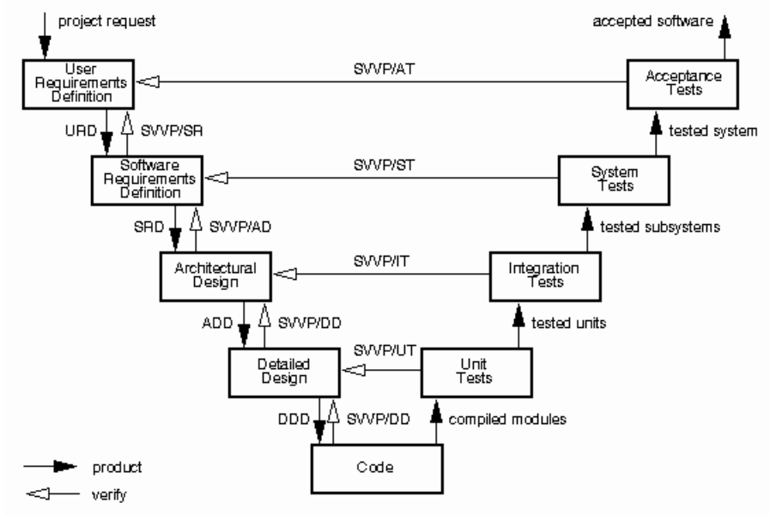

The project is divided in five phases, these phases are as follow:

1. UR (user requirements)
2. SR (software requirements)
3. AD (architectural design)
4. DD (detailed design)
5. TR (transfer)

These phases are crucial as documentation of the software. By implementing this kind of process model, when something is not good happening during the process we could go back to the latest or one before the latest phase. This will give us advantage as a project team to give us more flexibility if some features have to be added or diminished during the process of making our product.

2.2  Organizational Structure

In the following table, there are several members and roles are assigned to each of them.

|  |  |  |  |  |
| --- | --- | --- | --- | --- |
| Main Role | Additional Job | Name | email | Institution |
| Project Team Member | Hardware Developer | Aldwin Akbar Hermanudin | [aldwin.akbar@ui.ac.id](mailto:aldwin.akbar@ui.ac.id) | Faculty of Engineering University of Indonesia |
| Project Team Member | Software Developer | Rudy Nurhadi | [rudy.nurhadi@ui.ac.id](mailto:rudy.nurhadi@ui.ac.id) |
| Project Team Leader | Software Designer | Tomi | [tomi@ui.ac.id](mailto:tomi@ui.ac.id) |

This project employs three persons in which has their own main role and additional job. Main role is his/her position through this project and additional job is basically added in order to finish several technical things that may happen during doing this project. There must be good communication between all employees during doing this task.

2.3  Project Responsibilities

The following table is made in order to identify the individuals who are responsible for those functions and activities.

|  |  |  |
| --- | --- | --- |
| **Role** | **Description** | **Person** |
| Project Team Leader | Planning and coordinating team activities; Providing feedback about team progress; Motivating Team Member; Chairing reviews of the items made by his team.  Additional Job: Software designer | Tomi |
| Project Team Member | Main Job: Assisting the team leader, Checking Progress, Defining work packages and Goals;  Additional Job: Hardware Developer | Aldwin Akbar |
| Project Team Member | Main Job: Assisting the team leader by signaling problem in an early stage;  Additional Job: Software Developer | Rudy Nurhadi |

Table F-2.  Project Responsibilities.

***3.  Managerial Process***

3.1  Management Objectives and Priorities

The objective of managing this project so well is because we have to use our time and cost needed efficiently in order to serve a high quality product. As a team leader must be able to plan and monitoring the output quality and make sure that the project is running based on guidelines.

|  |  |  |  |
| --- | --- | --- | --- |
| **Project Dimension** | **Fixed** | **Constrained** | **Flexible** |
| Schedule | X |  |  |
| Cost |  | X |  |
| Changes Over Product |  |  | X |

Table F-3: Flexibility Matrix

3.2  Assumptions, Dependencies, and Constraints

In this project plan, the schedule must be really strict because we are avoiding of running out of time and we have to minimize the consumption of so many cost that may comes up during doing this project. Also, a number of factors are taken into account, for instance: we still have a responsibility out of this project since we are still an engineering student and lack of ability to manage a project well and we are now learning how to implement managerial thing over the technical.

3.3  Risk Management

In order to create and finalize this project, there will be several obstacles that will find. Those problems sometimes inhibit us to done the project punctually. In this section, we will like to describe something that can be grouped as problem. Those problems are identified based on the categories of risk classification. There will be risks with the work process itself, risks with the management, risks with the resources, and risks with the customer.

3.3.1  Risks with the work process

**1. Time shortage and deadlines**

*Probability:* High

*Prevention:* Take care about the schedule and focus while doing it.

*Correction:* When tasks fail to be done in time, there must be a discussion between the team members in order to maintain the efficiency of work.

*Impact:* High

**2. Design Errors**

*Probability:* Medium

*Prevention:* Critical reviewed for each development or design. Consult the problem with the capable advisor. Take a lot of critics that has positive impacts to this project

*Correction:* Contact the advisor or people that has capacity over this to help us to do some design corrections.

*Impact:* High

**3. Miscommunication**

*Probability:* Medium

*Prevention:* Every member of this project should be participated to every single internal meeting. After a meeting there must be some self-reviewed between all members about things that they like or dislike. The openness over all members is required. All members should not hesitate to ask and re-ask questions if things seem unclear.

*Correction:* Between team leader and team member or project team must gathered in a meeting that only focus on the solution of the miscommunication problem

*Impact:* High

3.3.2  Risks with the management

**4. The absence of Project Team Leader**

*Probability:* Low

*Prevention:* Choose either team leader or team member that has to come to the meeting if both are not possible to come and asks them to keep alerting about the progress of the project schedule and deadline.

*Correction:* To remind and give the last update over this project

*Impact:* Low

3.3.3  Risks with the resources

**5. Unavailability of the technical advisor when needed**

*Probability:* Medium

*Prevention:* Find the most capable advisor during to do this project that focus only on the technical stuff and after that keep in touch with him/her in order to have a good communication and relationship between project team and that advisor.

*Correction:* Contact another advisor that available meanwhile trying to solve the problem by searching it from different source. Due to time is not waiting us and deadline is coming through us.

*Impact:* High

3.3.4  Risks with the customer

**6. Lack of meeting intensity with the customer**

*Probability:* Medium

*Prevention:* Meeting with the customer has to be planned well in advance.

*Correction:* Meeting has to be rescheduled.

*Impact:* Medium

**7. The customer requirements are not possible**

*Probability:* High

*Prevention:* Obviously explained to the customer why or why not to implement things that he/she asked for. Make sure the acceptance of URD is not a decision that has to be made in a rush.

*Correction:* URD has to be analyzed and further discussion are urgently needed before the project is started.

*Impact:* Low

3.4  Monitoring and Controlling Mechanisms

The monitoring of project progress is done by the team leader using following means:

**Weekly Meeting with Project Team**

The project group meeting usually takes time on every Friday on 10:00 AM at Departemen Teknik Elektro Netlab UI. The project group meeting itself is agenda limit so we not focus on how long the meeting will takes our time but the agenda of the meeting should be check listed all. Although the time may be subject to changes, each of new information will be announced to the all project team through Project Team group chat. The team leader takes care about the agenda and presides the meeting.

**Progress Report Meeting with Customer**

The meeting with our customer will not be fixed to time but based on our needs. We will contact them directly if their presence is needed for us. Before do progress report meeting, all member of this project (team leader, team member) should submitted a progress report for today’s meeting and read the minutes of the previous meeting.

**Project Log**

Each of members (team leader and team member) should be filled their log after weekly internal meeting in order to be controlled by team leader.

3.5  Staffing Approach

During the finishing of the process of the process, some skill may be required to the members that join the project team. The most skill that has to conduct is the willingness of learning something. Since we are all new on this project, a person with a willingness of learning will be someone that is exact for our team. We will find a lot of problem especially technical ones, but if they eager to learn, those problem will become a challenge. This kind of thing will be our main requirement. Also we are searching for person who not just able to do technical process but also have a good sense of team work and good communication skill is preferred.

***4.  Technical Process***

4.1  Methods, Tools, and Techniques

In this project, we design using v-model that has been inlcuded in section 2.1. The software that is needed during the process of making this project are Android Studio/Eclipse. During the project software development is required, for example programming language used in Android devices.

4.2  Software Documentation

Software documentation is one of the most important parts during process finishing of this project. SD itself describes the whole idea and design about the software that we are making. Before the SD is made, URD must accepted first. The presence of SD is planned to give all information about how our system work and lead the reader to understand the main goal of this project. Since the SD is entirely depended on URD, to ensure that the implementation of the software satisfies the requirements, the following documentation is required as a minimum:

4.2.1  Software Requirements Specification (SRS)

The SRS clearly and precisely describes each of the essential requirements (functions, performances, design constraints, and attributes) of the software and the external interfaces. For this project, SRS is here as a guidelines to finish the project. Since we made the voice recognition in android, the software requirements are listed: Windows OS minimum Windows 7 with Android Studio or Eclipse installed.

4.2.2  Software Design Description (SDD)

The SDD describes the major components of the software design including databases and internal interfaces. For this project, SDD is here that include all the design (Architectural and Detailed Design) during the process of making this software.

4.2.3  Software Test Plan

The Software Test Plan describes the methods to be used for testing at all levels of development and integration: requirements as expressed in the SRS, designs as expressed in the SDD, code as expressed in the implemented product. By the end of this project, we will test the software before the transfer process in which divided into 3 parts: Integration Test Plan, Unit Test Plan and Software Test Documentation. The integration test plan are done by the end of ADD phase, the Unit Test Plan are done by the end of DDD phase in way more advanced than ADD. After the all test plan are done, Software Test Documentation are made and give the summary whether our software is quite satisfying or not.

4.3  User Documentation

Since the user of this software will have different perspectives from one to another. So the user documentation has to be very clear and easily understand by them. And that document should conform several aspects like: Have a good quality and must be reviewed. Also in user documentation must include the user manual about how to use our software.

4.4  Project Support Functions

Provide either directly or by reference, plans for the supporting functions for the software project.  These functions may include, but are not limited to, configuration management, software quality assurance, and verification and validation.  Plans for project support functions are developed to a level of detail consistent with the other sections of the SPMP.  In particular, the responsibilities, resource requirements, schedules and budgets for each supporting function must be specified.  The nature and type of support functions required will vary from project to project, however, the absence of a software quality assurance, configuration management, or, verification and validation plan must be explicitly justified in project plans that do not include them.

***5.  Work Packages, Schedule, and Budget***

5.1  Work Packages

Work Packages is not identified yet for the first draft of SPMP. Any changes are subjected soon

5.2  Dependencies

The URD must be complete and accepted before the SRD can start. However, while working on the SRD, new questions arise about the user requirements. So the SRD does not strictly depend on the URD. The SRD must be fixed first before enter the AD phase. On the other words, the ADD can’t begin if the SRD is still not completed. DDD can be started right after the ADD is completely described. After the product is done, there should be STD phase but before it make sure the DD phase is completed.

5.3  Resource Requirements

The most important resource during the project is human resources. The software that is needed during the process of making this project are Android Studio or Eclipse. Other resources needed include development stations, a store where documents and information can be backed up, a printer and 3d printer, network connectivity, a working and meeting room with chairs. During the project software is required like text editor and compiler for any programming language.

5.4  Budget and Resource Allocation

The allocation of budget and resources to the various project functions, activities, and tasks is not yet identified. Any changes are subjected soon.

5.5  Schedule

The schedule milestone for software developing project is not yet identified. Any changes are subjected soon.

***6.  Additional Components.***

6.1  Index.

Index is not identified yet for the first draft of SPMP. Any changes are subjected soon.

6.2  Appendices

Appendices is not identified yet for the first draft of SPMP. Any changes are subjected soon.